CaseManagement_CreationOfCase_Instance23_06-Aug-2018_03-36-54_AM_MouseClickActionMoveToElementBycssSelectorspanTabSFA.png

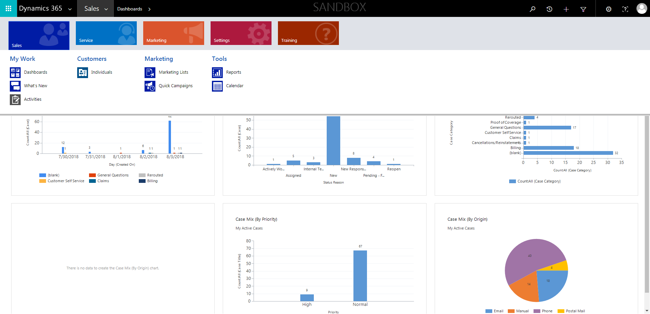

CaseManagement_CreationOfCase_Instance23_06-Aug-2018_03-37-10_AM_MouseClickActionMoveToElementBycssSelectorspanTabCS.png

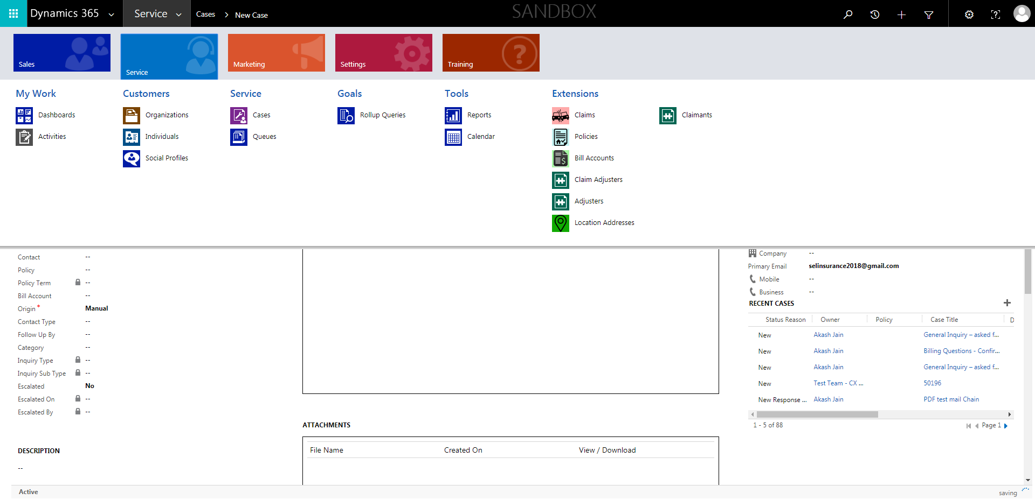

CaseManagement_CreationOfCase_Instance23_06-Aug-2018_03-37-19_AM_ValidatingCaseentitynavigation.png

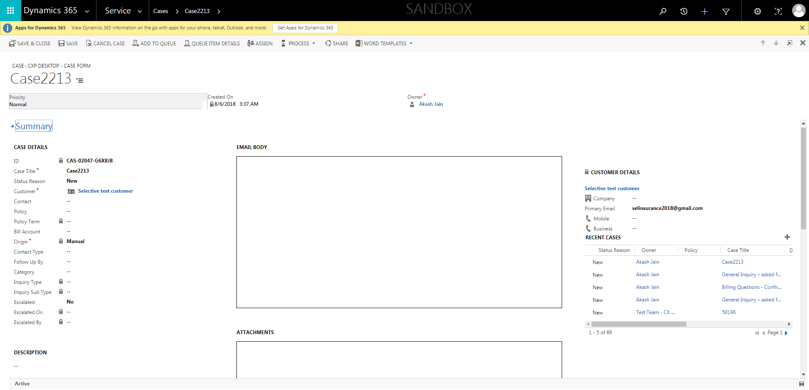

CaseManagement_CreationOfCase_Instance23_06-Aug-2018_03-36-46_AM_SingleSignOn.png

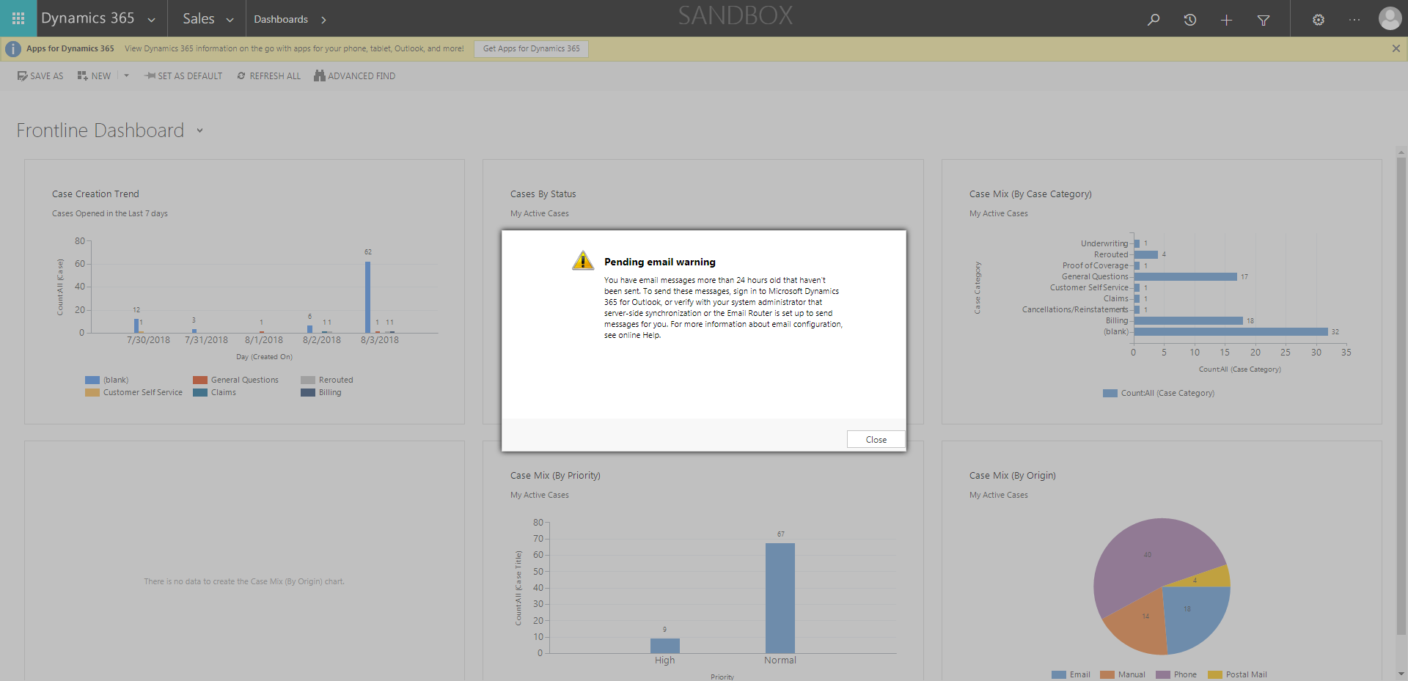

CaseManagement_CreationOfCase_Instance23_06-Aug-2018_03-37-17_AM_ValidatingCaseentitynavigation.png

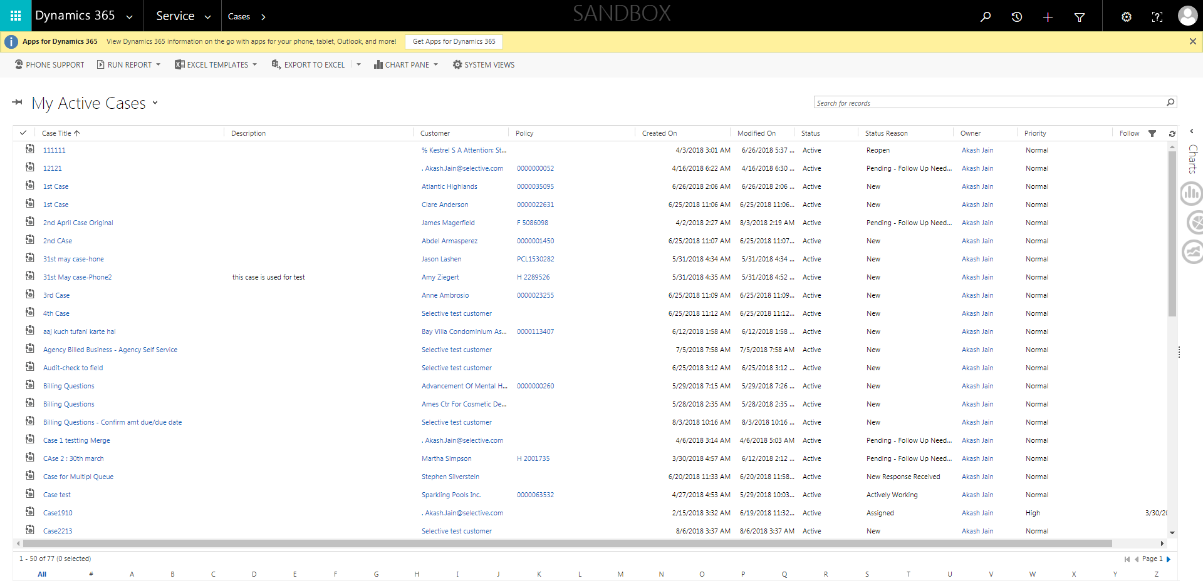

CaseManagement_CreationOfCase_Instance23_06-Aug-2018_03-36-56_AM_MouseClickActionMoveToElementBycssSelectoranavcases.png

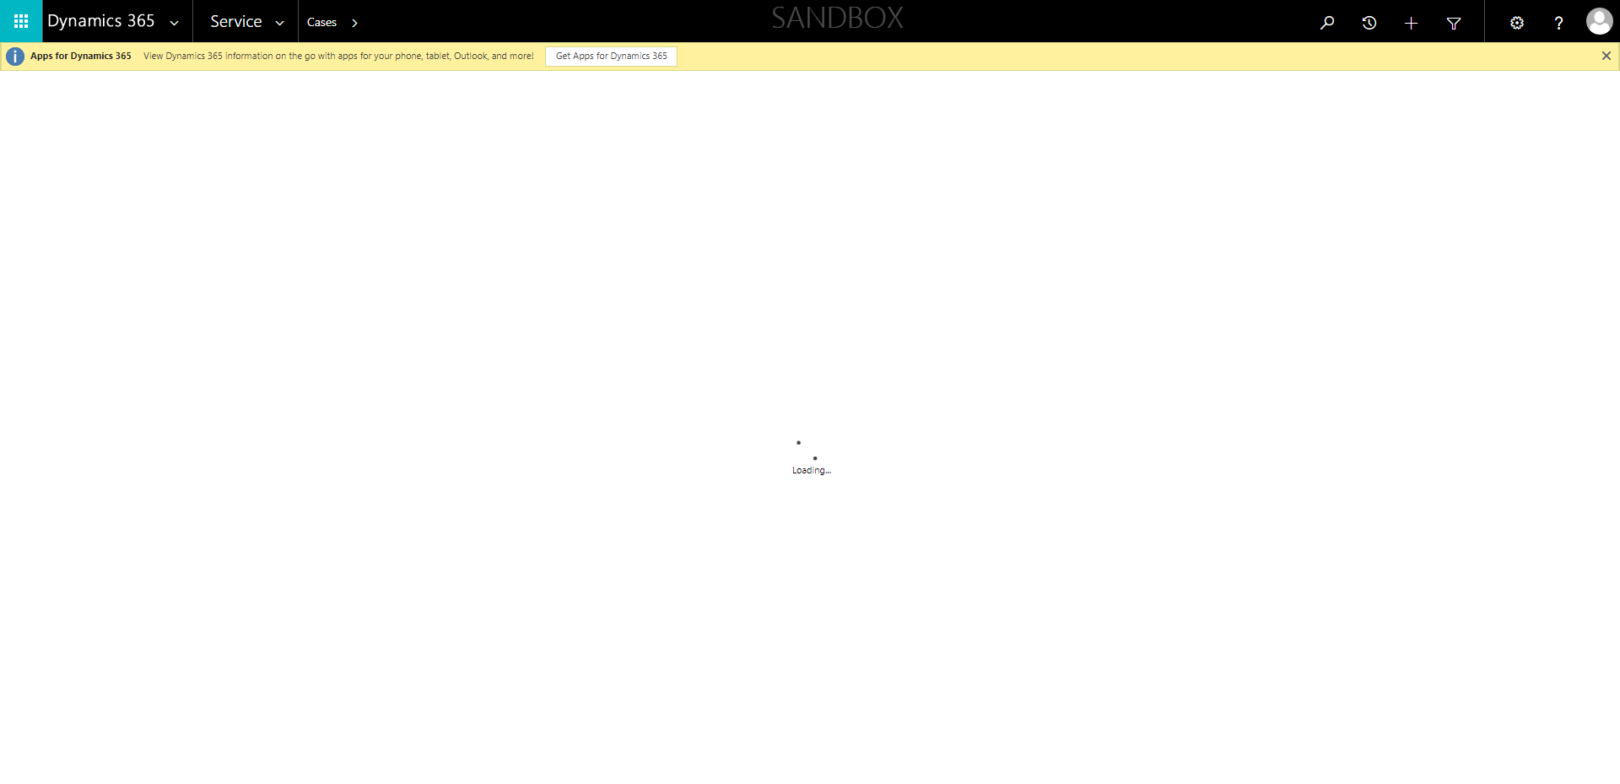

CaseManagement_CreationOfCase_Instance23_06-Aug-2018_03-37-11_AM_MouseClickActionMoveToElementByxpathimgaltServiceparentspan.png

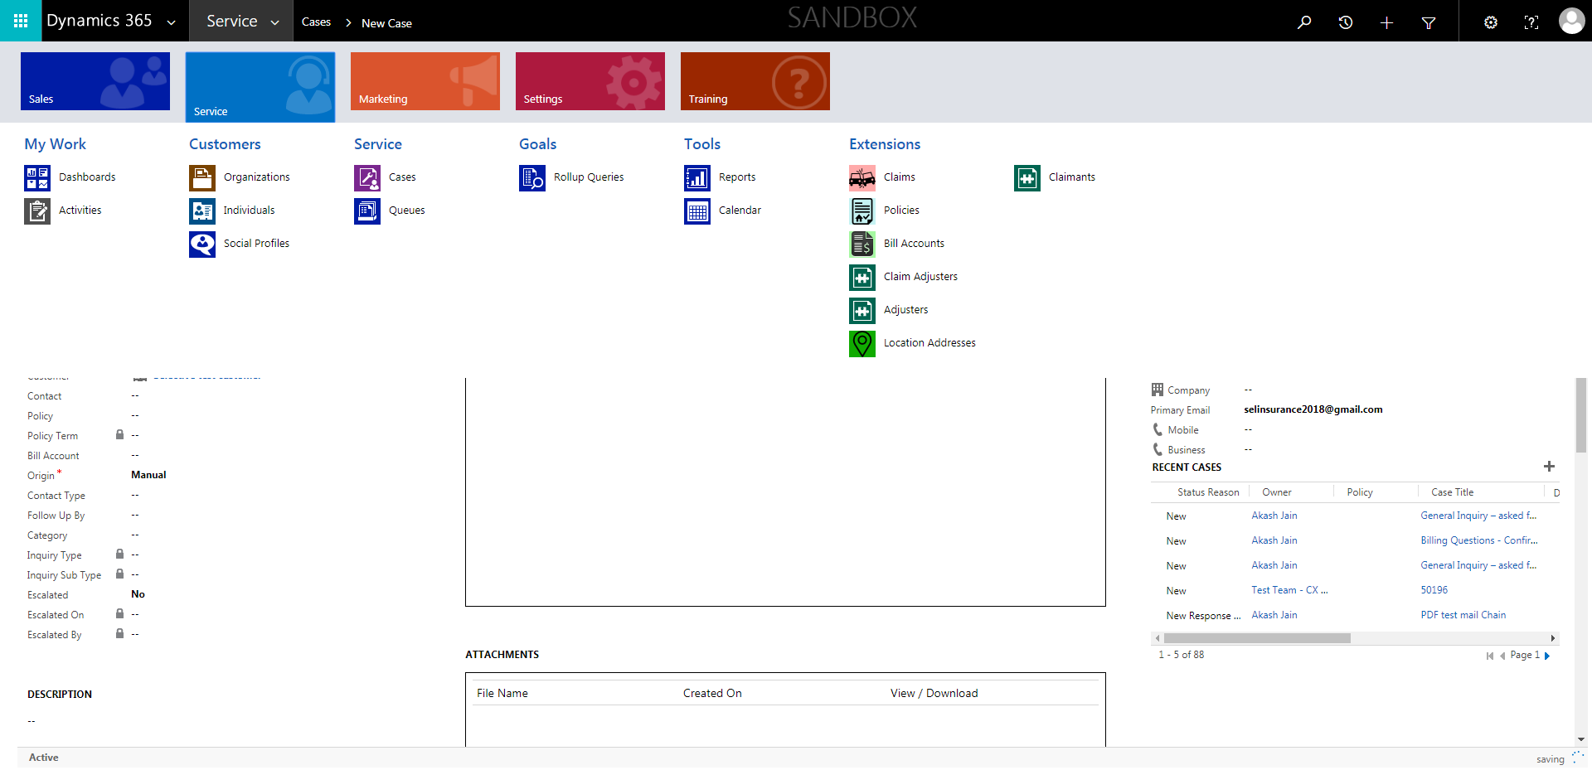

CaseManagement_CreationOfCase_Instance23_06-Aug-2018_03-36-10_AM_MouseClickActiononStaleElement.png

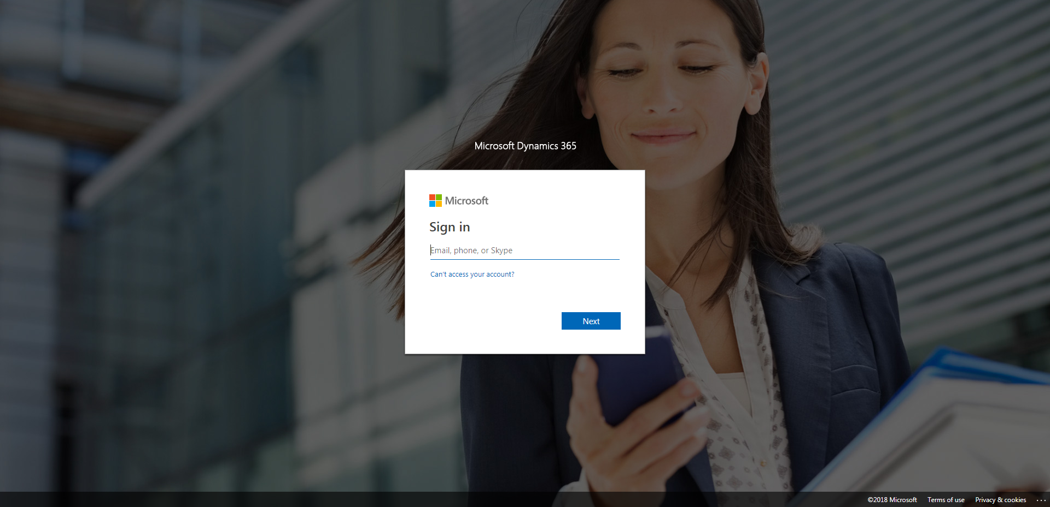

CaseManagement_CreationOfCase_Instance23_06-Aug-2018_03-36-55_AM_MouseClickActionMoveToElementByxpathimgaltServiceparentspan.png

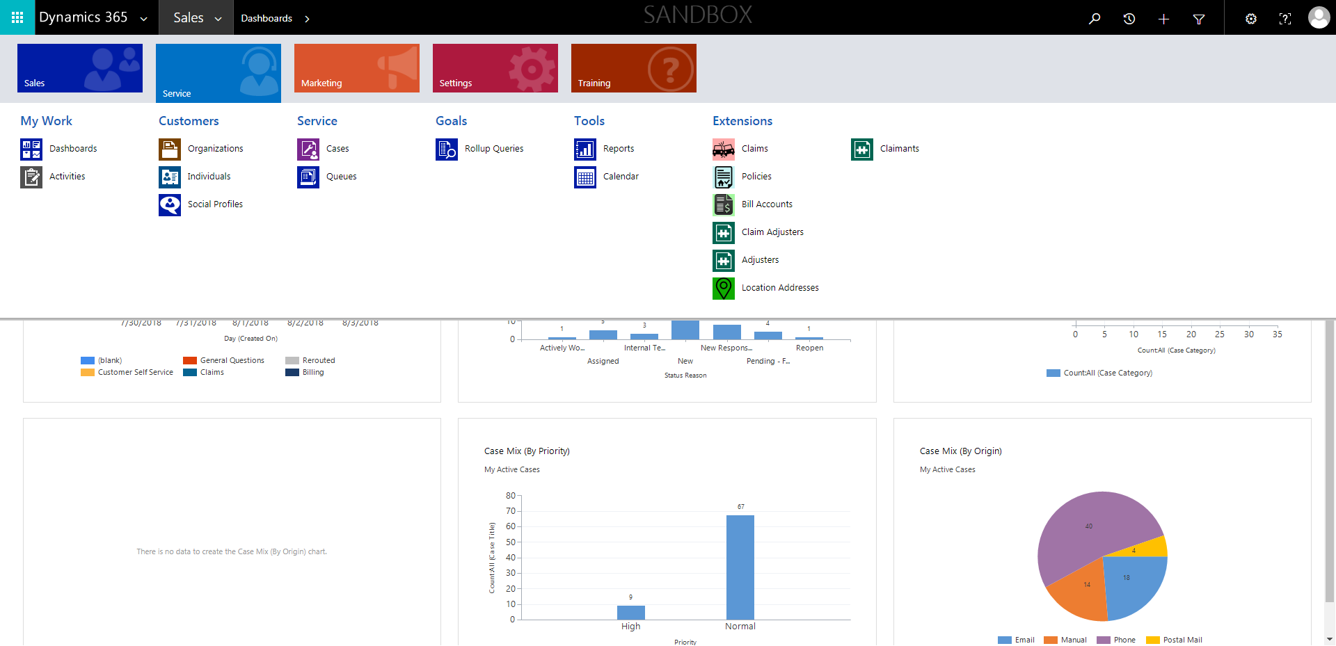

CaseManagement_CreationOfCase_Instance23_06-Aug-2018_03-36-13_AM_MouseClickActiononStaleElement.png

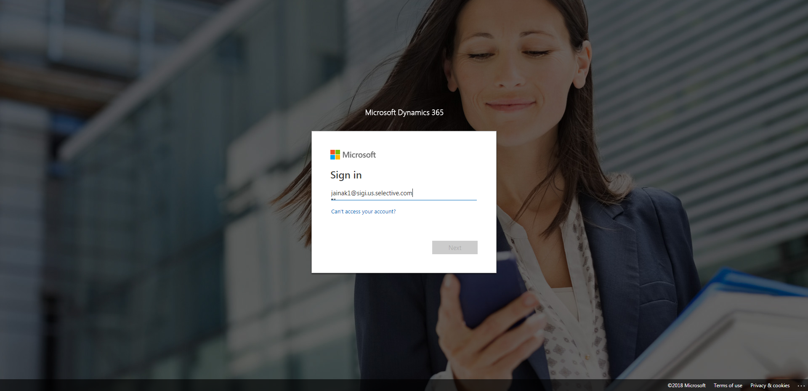

CaseManagement_CreationOfCase_Instance23_06-Aug-2018_03-37-16_AM_MouseClickActionMoveToElementBycssSelectoranavcases.png



CaseManagement_CreationOfCase_Instance23_06-Aug-2018_03-36-50_AM_SingleSignOn.png

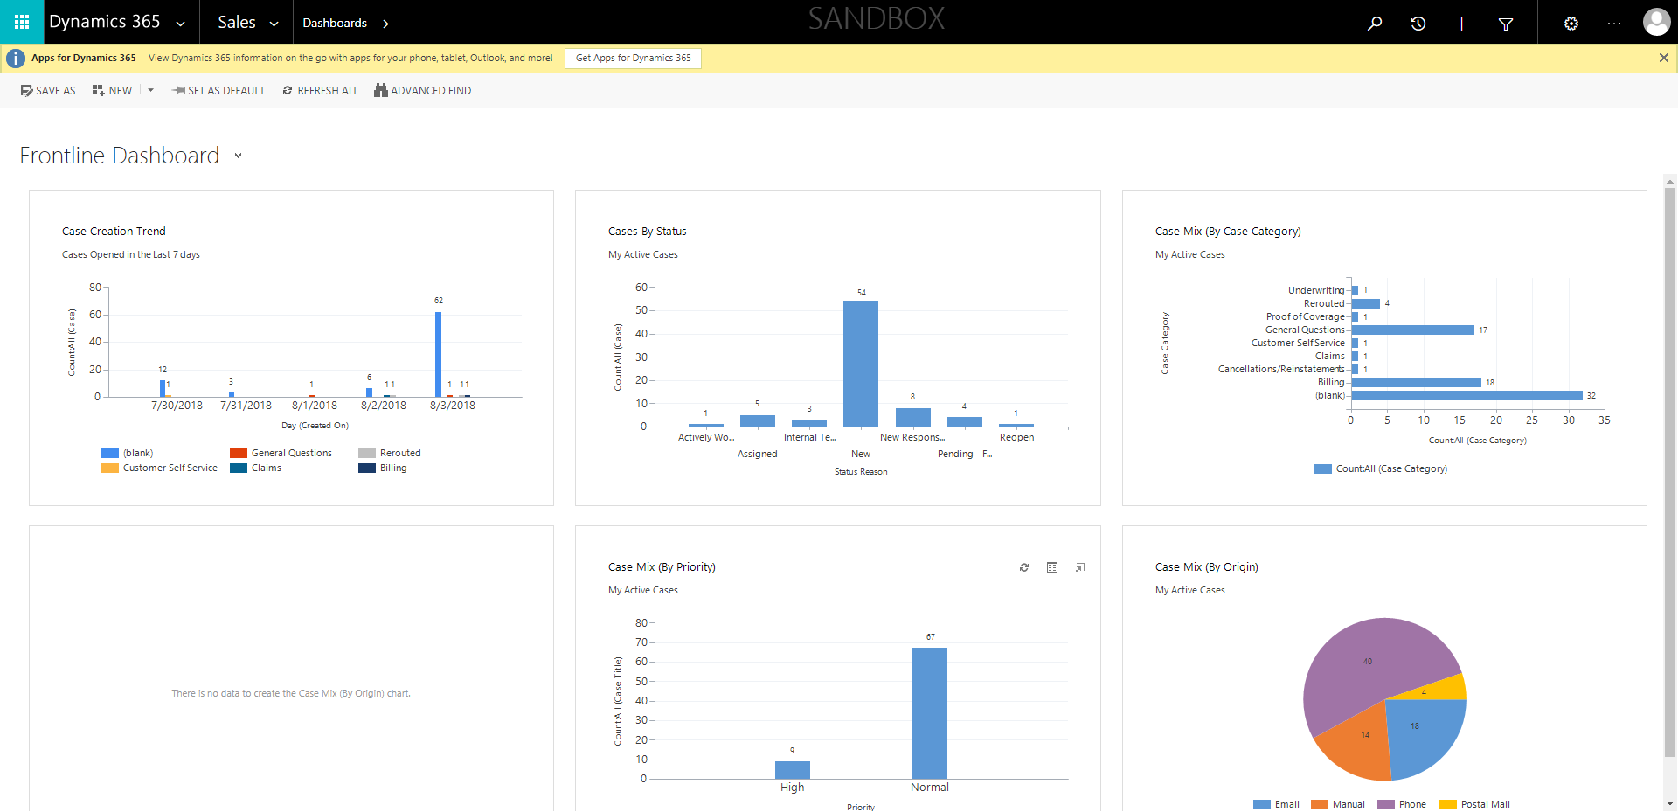

CaseManagement_CreationOfCase_Instance23_06-Aug-2018_03-36-12_AM_EnterTextAction.png

